Ex. No. 9 | Working with MongoDB Using Shell Commands
Date of Exercise | 03/10/2026
GitHub Host Link

Aim
To study MongoDB and perform basic database operations using MongoDB Shell (mongosh), including database and collection, creation, document insertion, retrieval, filtering, sorting, updating, deletion, indexing, and simple aggregation.
Description
The experiment aims to study and implement basic MongoDB operations using MongoDB Shell (mongosh). MongoDB is a NoSQL database that stores data in the form of documents within collections. In this experiment, a database named collegeDB and a collection named students were created to store student details such as roll number, name, department, year, and marks.
The following operations were performed to understand database creation, data manipulation, retrieval, and management.
Operations Performed
1. Database Creation: Created and selected the collegeDB database using the use command.
2. Collection Creation: Created a students collection using db.createCollection().
3. Document Insertion: Inserted student records using insertOne() and insertMany().
4. Data Retrieval: Retrieved all student records using find() and a specific record using findOne().
5. Conditional Queries: Retrieved student details based on department and marks using comparison operators such as $gt, $lt, $gte, $lte, and $ne.
6. Logical Operations: Used AND and OR conditions to retrieve records that satisfy multiple criteria.
7. Projection: Displayed only the required fields, such as student names and marks, using projection.
8. Sorting and Limiting: Arranged student records in ascending or descending order and limited the number of results.
9. Counting Documents: Counted all documents or documents matching a particular condition using countDocuments().
10. Updating Documents: Modified existing student records using updateOne() and updateMany().
11. Deleting Documents: Removed individual or multiple records using deleteOne() and deleteMany().
12. Distinct Values: Retrieved unique department names using distinct().
13. Aggregation: Calculated department-wise average marks, maximum marks, and the number of students using aggregation operators.
14. Indexing: Created an index on the rollno field and viewed the available indexes.
Procedure:
1. Open Windows PowerShell and verify the MongoDB Shell installation using the mongosh --version command.
2. Connect to the MongoDB server by executing the mongosh command.
3. Display the existing databases using the show dbs command.
4. Create and select the database named collegeDB using the use collegeDB command.
5. Create a collection named students using db.createCollection("students") and verify it using show collections.
6. Insert a single student document using insertOne() and insert multiple student documents using insertMany().
7. Retrieve all student documents using find() and retrieve a specific document using findOne().
8. Perform conditional searches using comparison operators such as $gt, $lt, $gte, $lte, and $ne.
9. Retrieve documents using logical AND and OR conditions and display selected fields using projection.
10. Sort the student records in ascending or descending order using sort() and restrict the number of results using limit().
11. Count all student documents and department-specific records using countDocuments().
12. Modify student records using updateOne() and updateMany(). Use $set to modify field values and $inc to increment numerical values.
13. Delete individual or multiple student documents using deleteOne() and deleteMany().
14. Retrieve unique department names using distinct() and perform aggregation operations to calculate average marks, maximum marks, and department-wise student counts.
15. Create an index on the rollno field using createIndex() and view the indexes using getIndexes().
16. Verify the results of the executed commands. If required, drop the collection or database at the end of the experiment using drop() or dropDatabase().
Perform the following operations independently:
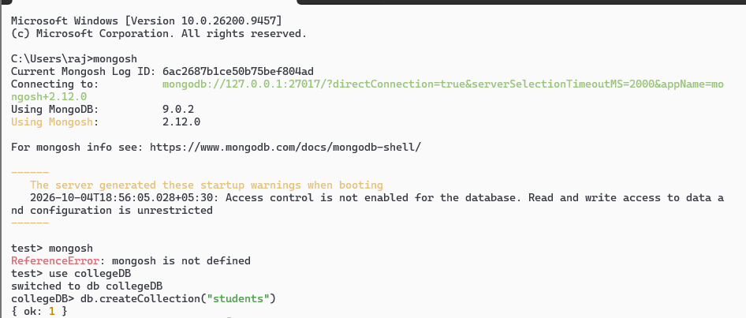
1.Insert at least 10 student documents.
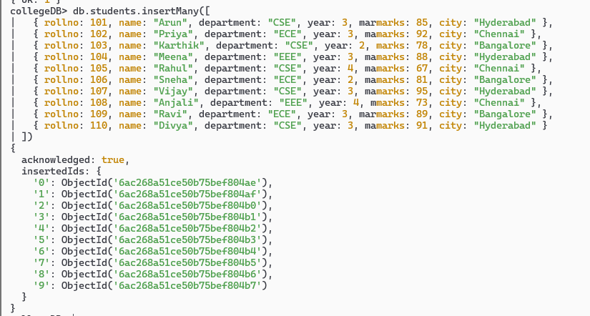
2. Display all students.
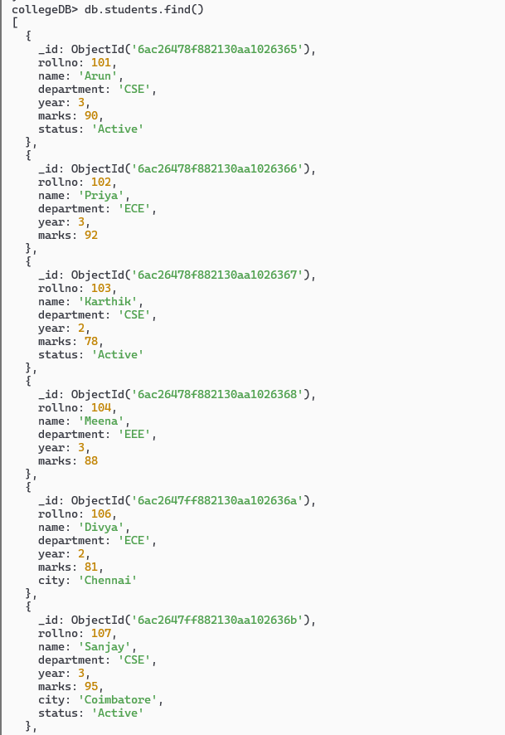
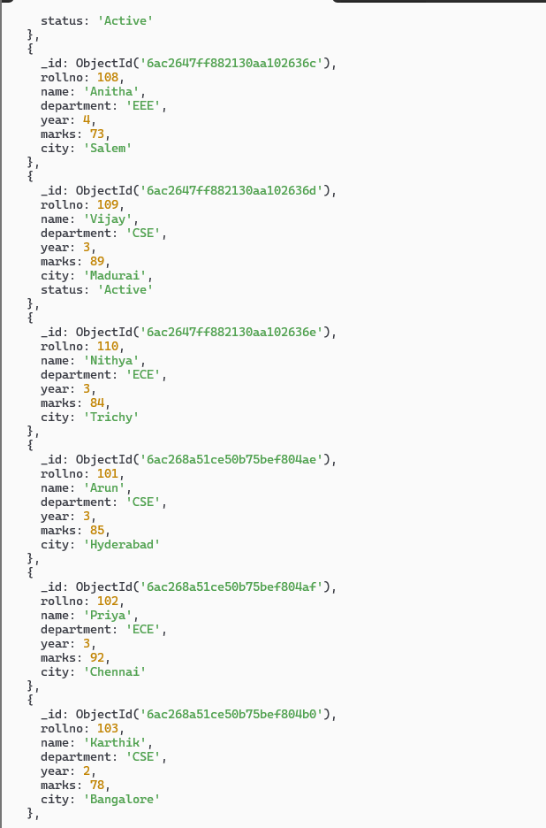
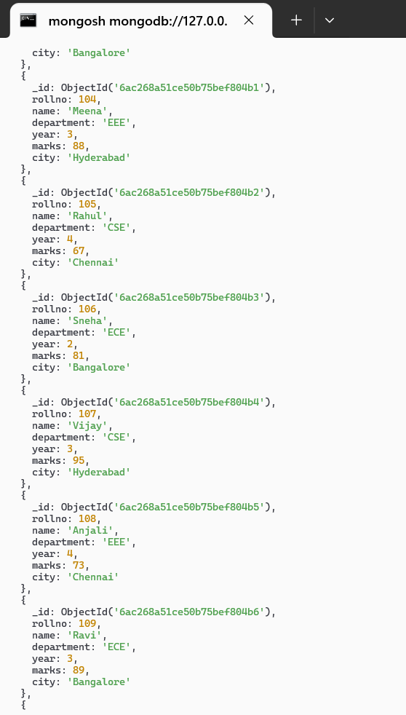
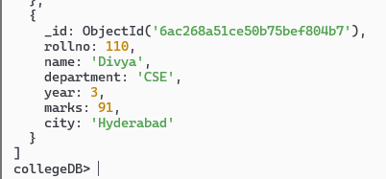

3. Display students belonging to CSE.
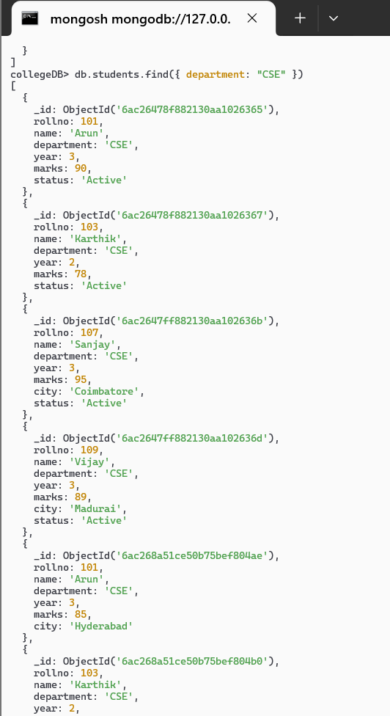
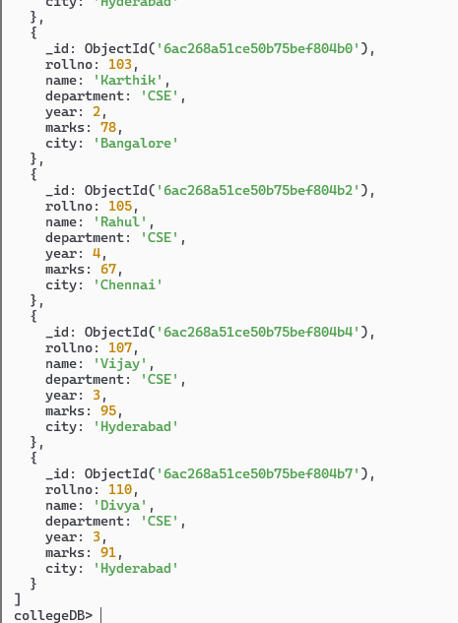

4. Find students having marks greater than 80.
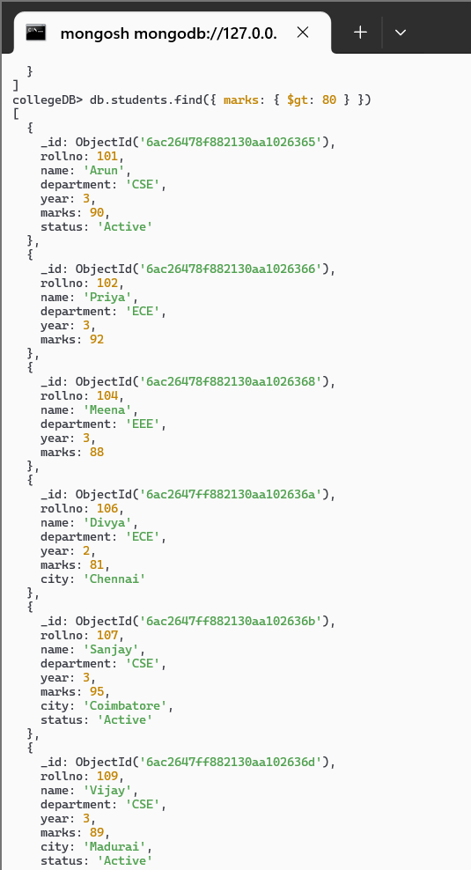
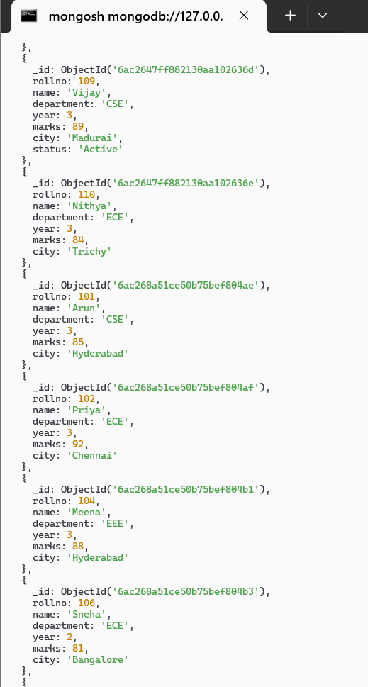
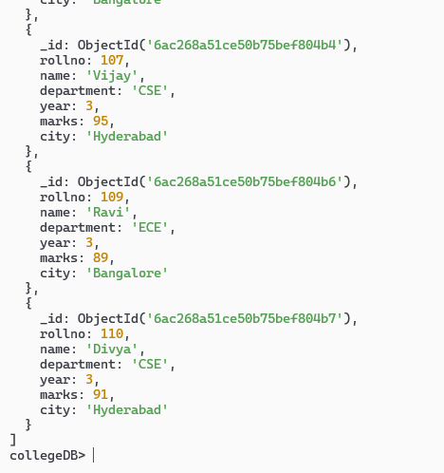
5. Display only student name and marks.
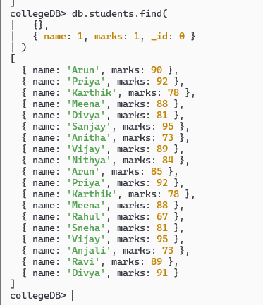

6. Find students belonging to CSE and third year.
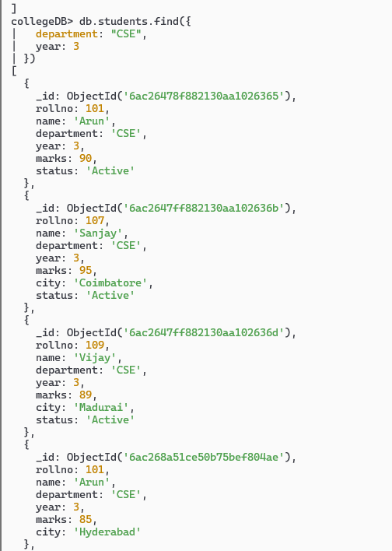
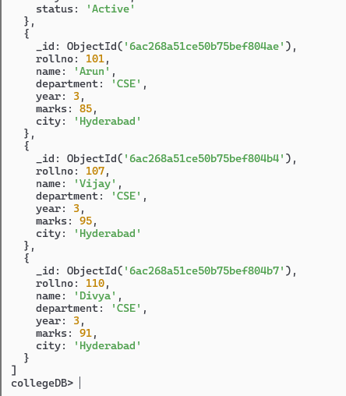
7. Find students belonging to CSE or ECE.
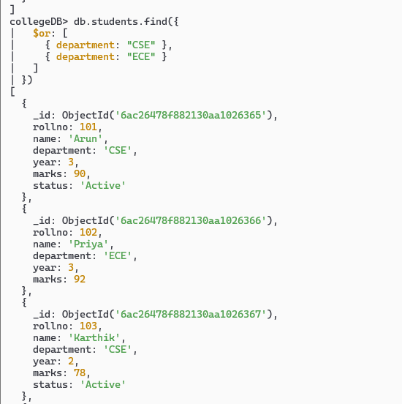
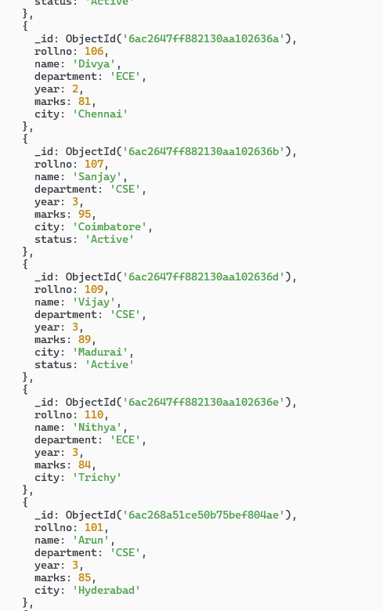
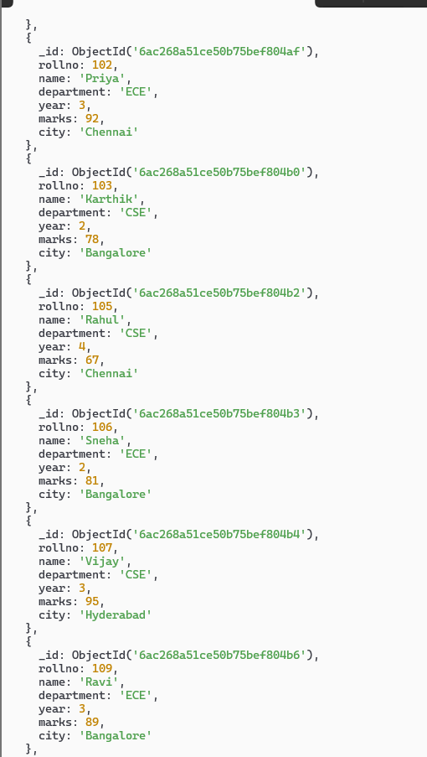
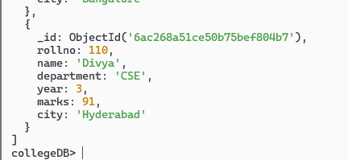

8. Sort students based on marks.
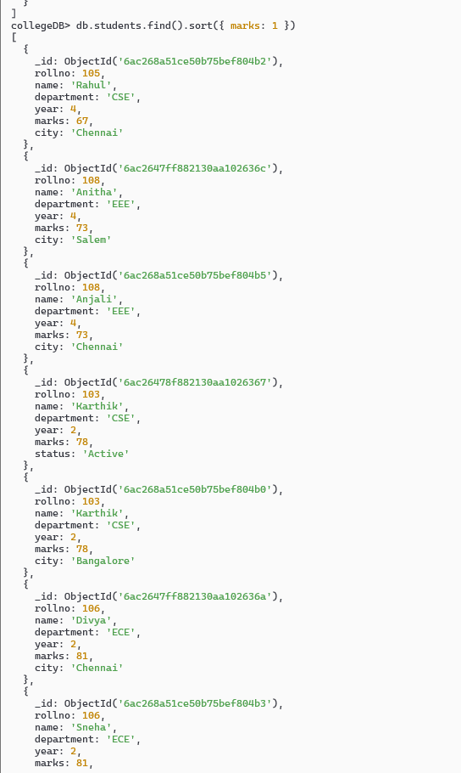
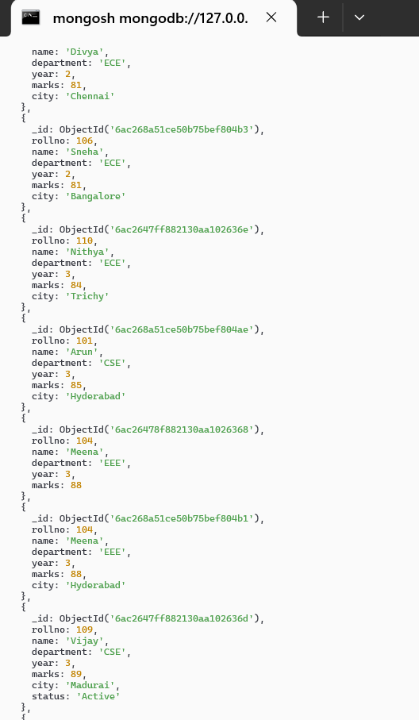
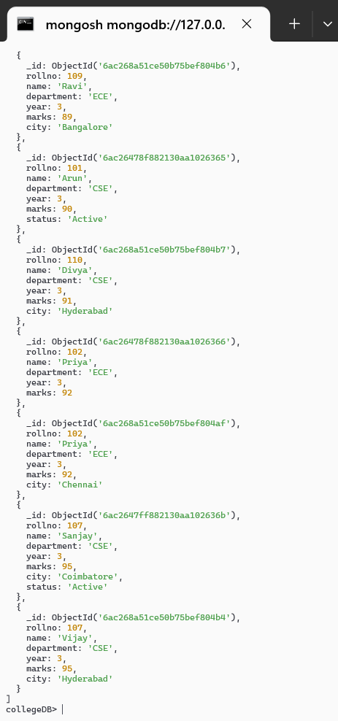

9. Display the top three students based on marks.
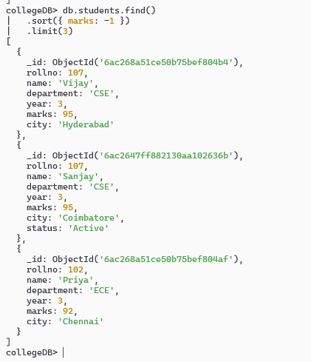
10. Count the number of CSE students.
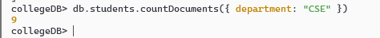
11. Update the marks of one student.
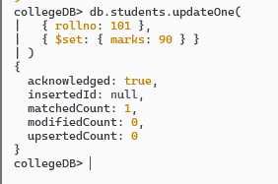

12. Add a status field to all CSE students.
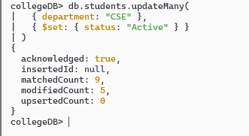
13. Delete a student using roll number.
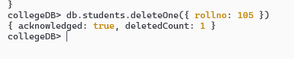
14. Display the distinct departments.
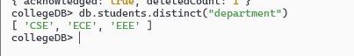
15. Calculate department-wise average marks.
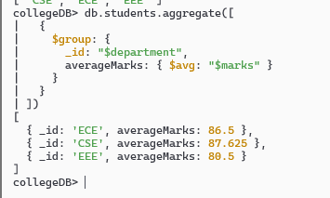
Result
The experiment was successfully completed using MongoDB Shell (mongosh). A database named collegeDB and a collection named students were created. Student records were inserted, retrieved, filtered, updated, deleted, and sorted using MongoDB commands. Aggregation, counting, distinct values, and other database operations were performed successfully.

